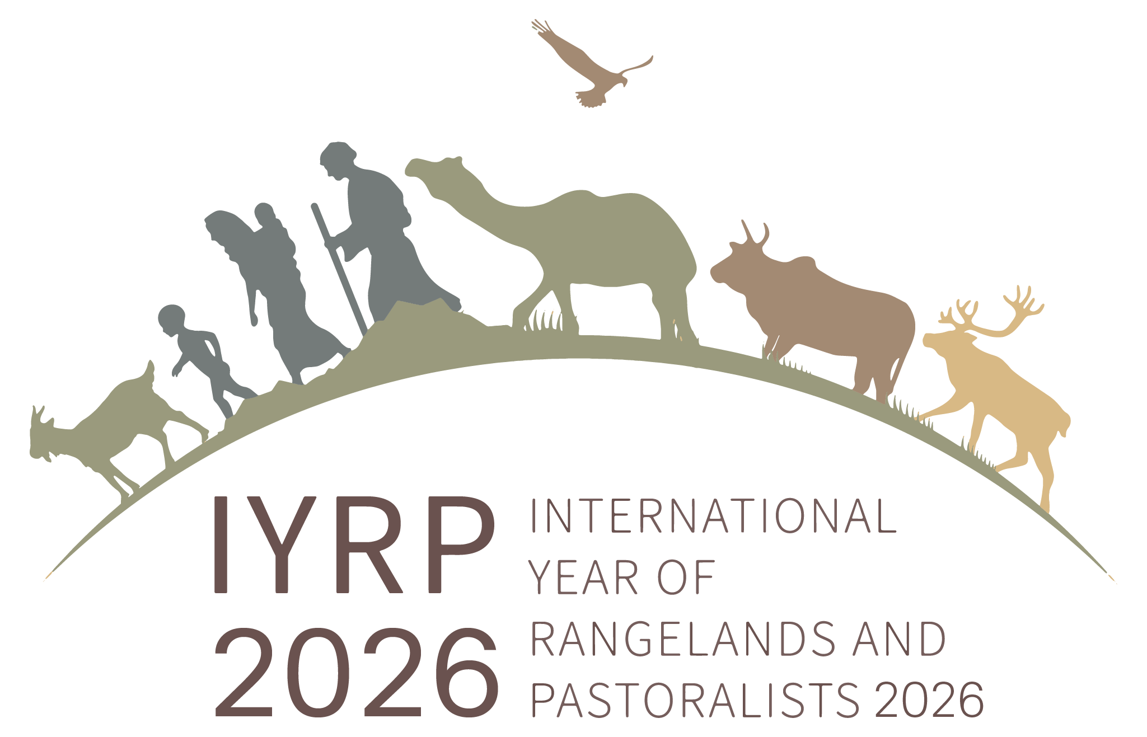

Current co-chairs of IYRC Global Coordinating Group:
Maryam Niamir-Fuller and Igshaan Samuels

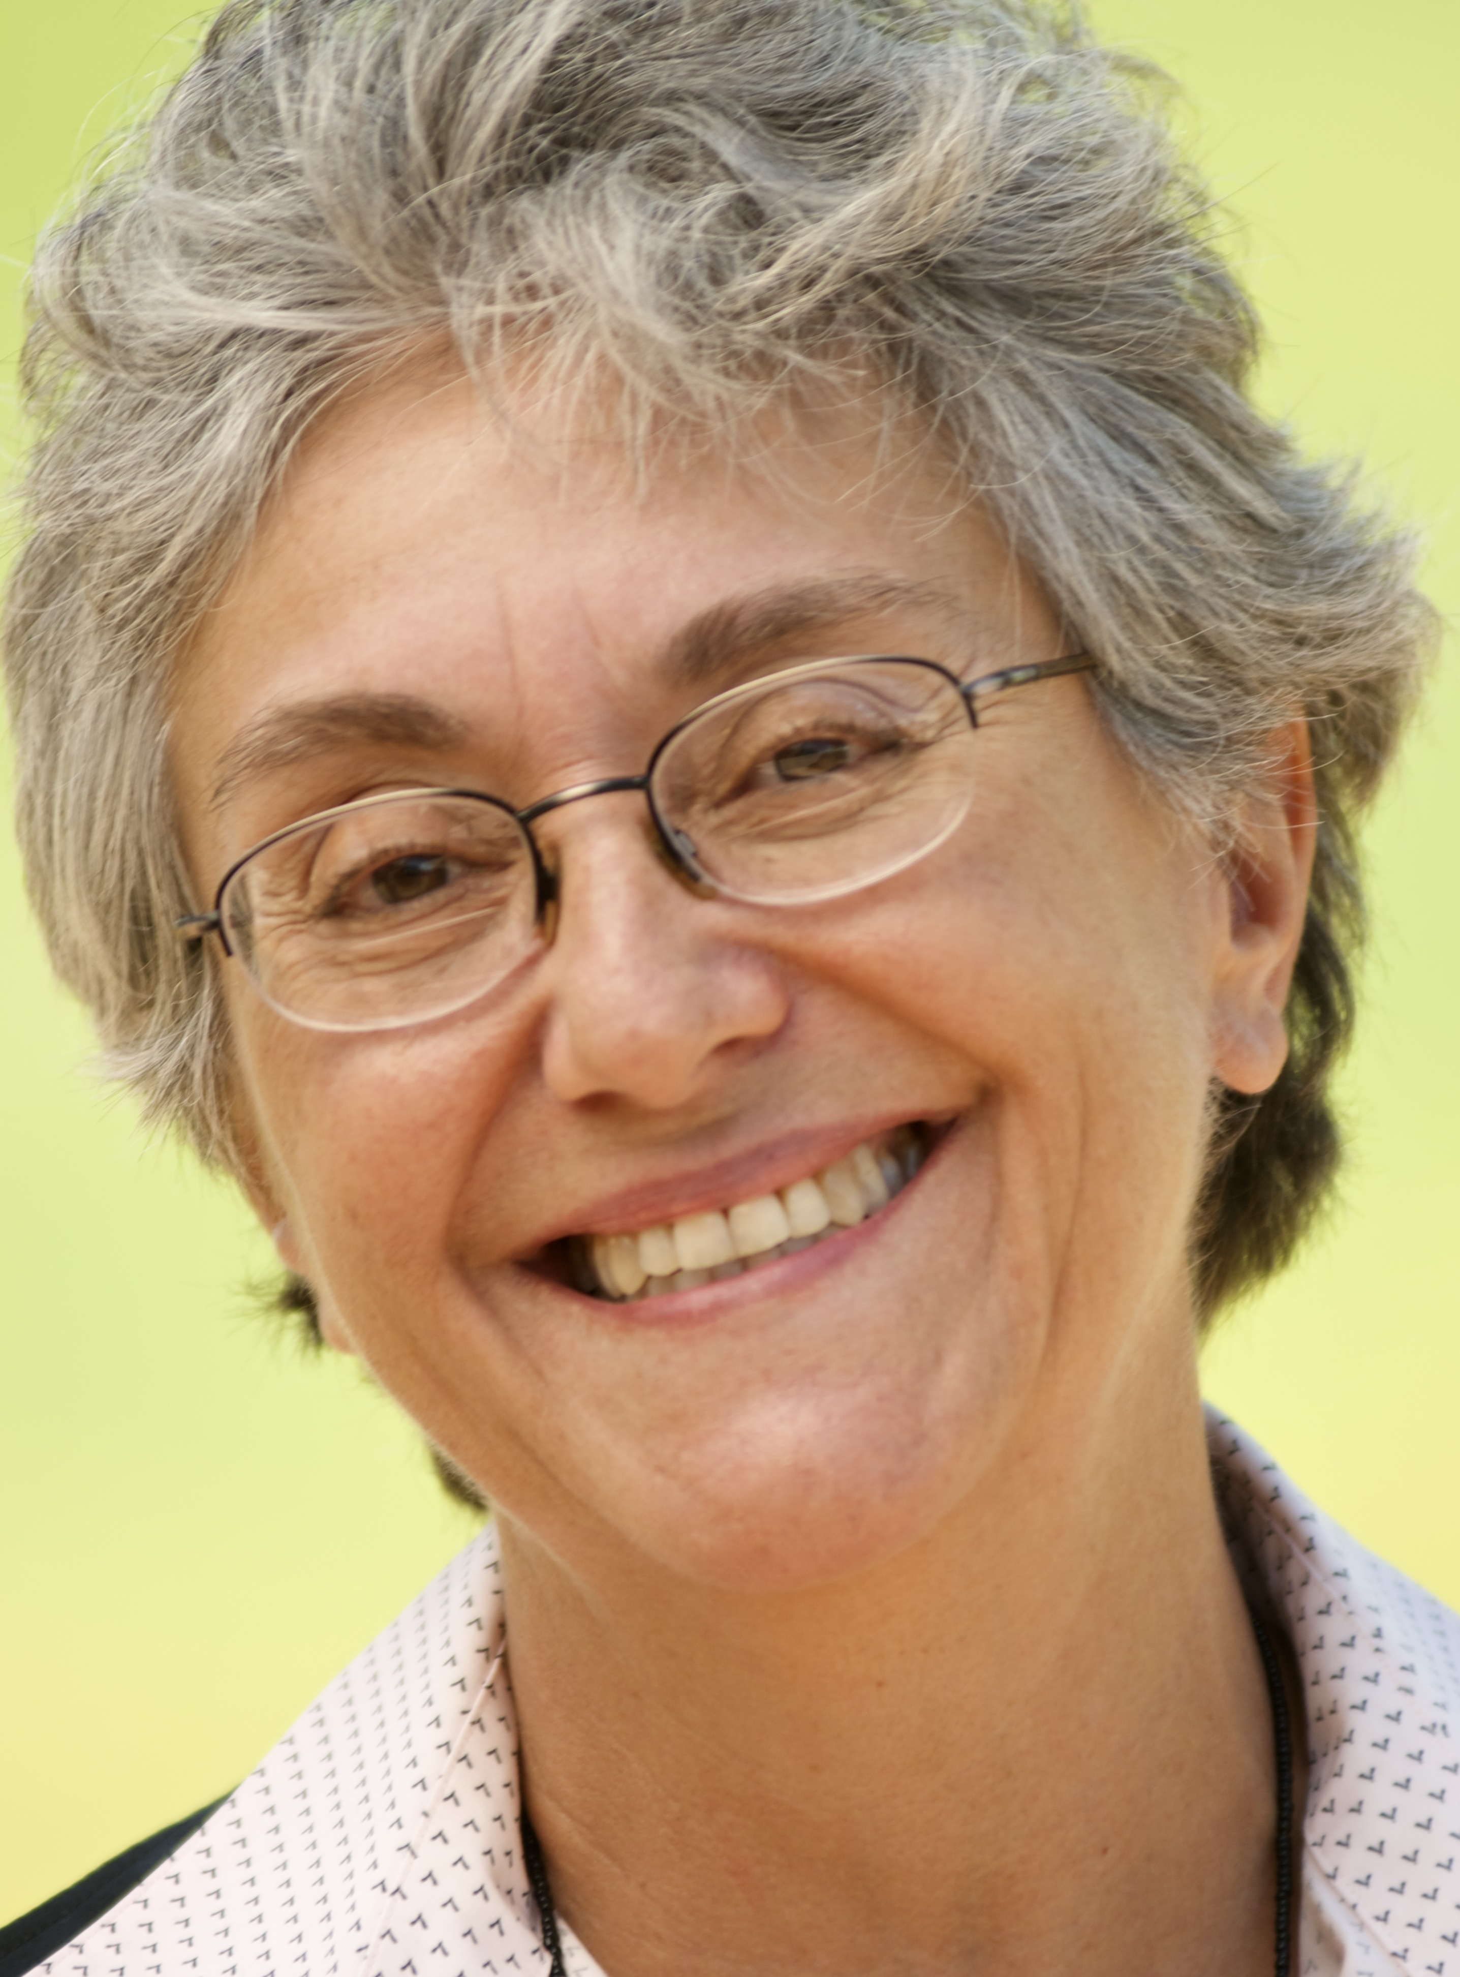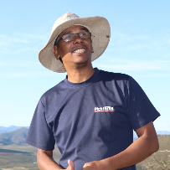

Since June 2022, the Global Coordinating Group (GCG) for the International Year of Rangelands and Pastoralists (IYRP) initiative is co-chaired by Maryam Niamir-Fuller & Igshaan Samuels.
Maryam is well known to everyone in the IYRP initiative, as she was Vice-Chair of the IYRP International Support Group for many years and played a leading role in achieving recognition of the IYRP by the United Nations General Assembly (UNGA). She holds a PhD in Rangeland Management from the University of Arizona, and initially worked as researcher in rural development in southern Sudan, then as Chief of Party for a livestock development project in Senegal (both funded by USAID) and designing projects of the Global Environment Facility (GEF) in Argentina, Morocco, Kenya and Uganda. She worked for the UN in various positions in 1993–2015, when she retired as Director of GEF in the UN Environment Programme and Special Advisor to the Executive Director on the Sustainable Development Goals.
Igshaan is a researcher in rangeland ecology and management with the Agricultural Research Council (ARC) in South Africa. He holds a PhD in Botany from the University of Cape Town and has worked in the drylands for 20 years. His research puts him in touch with grassroots activities and the challenges of pastoralists, particularly the indigenous Nama peoples of South Africa. He is president of the Grassland Society of Southern Africa (GSSA), represents sub-Saharan Africa in the International Rangeland Congress (IRC) Continuing Committee and is in the core leadership team of the Regional IYRP Support Group for Eastern and Southern Africa.

